MIM V3 — test case TC-01: investigate INC2676403 on vslrau1p220
Dashboard | MIM V3, Kibana 9.5.3
Objective | Show that picking one incident points the whole dashboard at it: the overview, the affected CI, its applications and services, its server's health, and who to escalate to
Why this incident | Round 12 ranked it first. Its CI is a monitored Linux server with 2 APM services, JBoss, logs, synthetic monitors and rich CMDB links, so almost every panel has something to show
Result | Pass. 23 of 28 panels filled; the 5 empty ones have no data for this CI, as expected
How the dashboard is read
The dashboard is read top to bottom, like an investigation:
- Section 1: what is open right now, across all incidents.
- Section 2: what the affected CI is, who owns it, and what it is connected to.
- Section 3: how its applications, services and server are doing.
The controls at the top decide what sections 2 and 3 show. Picking an incident is enough: its CI drives everything.
Test flow
The path followed in this test, with what each step showed.
- Green: the step and its result.
- Amber: a decision.
- Grey, dashed: the branch this test did not need.
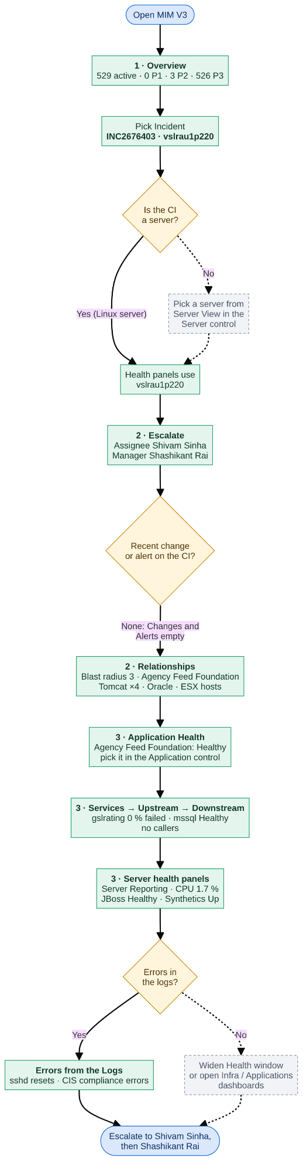
Flowchart source (Mermaid)
Loading
Inputs
Control | Value | Why
Incident | INC2676403 · vslrau1p220 | The incident under test; its affected CI is vslrau1p220
CI | (no CI selected) | Not needed: an incident's CI always wins
Server | (no server selected) | Not needed: vslrau1p220 is itself a server, so the health panels use it
Health window | 24 hours | How far back the health panels look; long enough to catch errors from before the incident
Service | gslrating | One of the two APM services on this server; drives Upstream / Service health / Downstream
Application | Agency Feed Foundation | The business application of those services; drives Services of the Application

Step 1 — Major Incident Overview
What to show: the starting point for the MIM lead. Before picking anything, section 1 answers "how bad is it across the estate?"
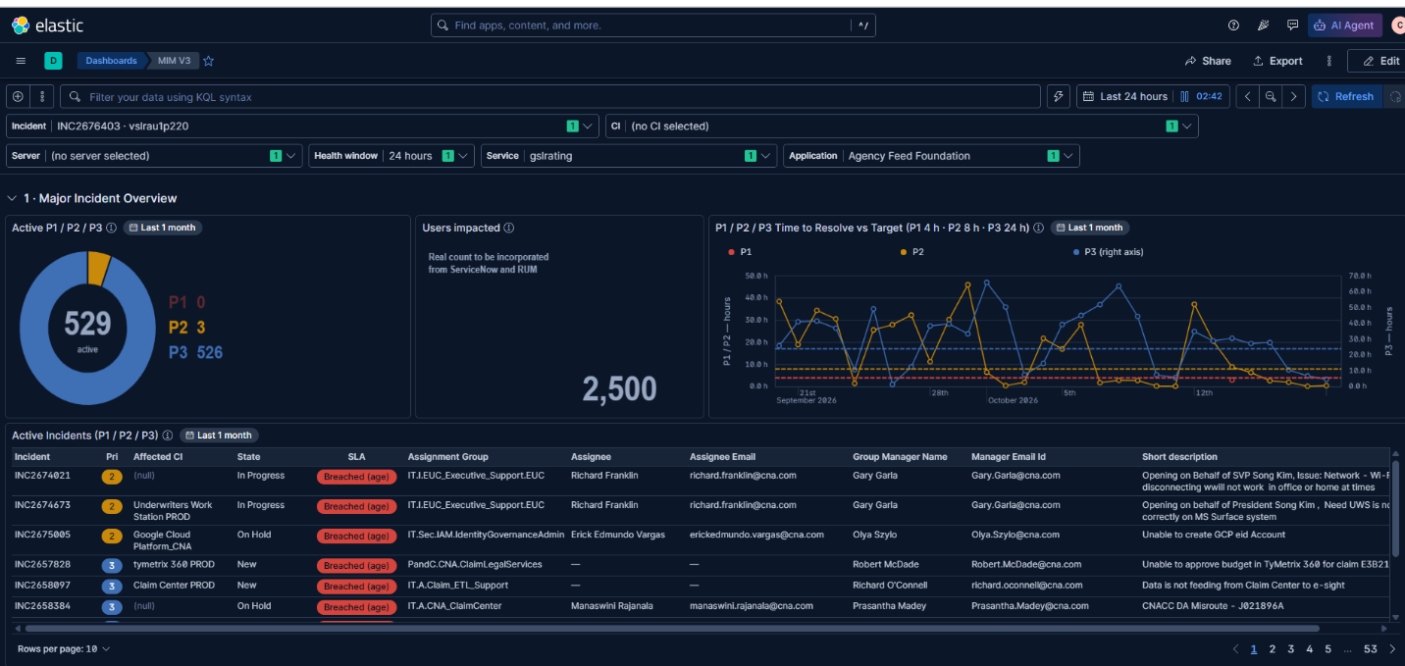
Check | Result
Controls hold the inputs above | ✅
Active P1 / P2 / P3: 529 active (P1 0, P2 3, P3 526) | ✅
Time to Resolve vs Target: P1 / P2 on the left axis, P3 on the right axis, dashed targets | ✅
Active Incidents: SLA, assignee and manager per incident | ✅
Users impacted: demo number (2,500) | ✅ placeholder
Notes:
- Donut: no P1 is open; most of the load is P3.
- Time to Resolve: points above a dashed line missed their target (P1 4 h, P2 8 h, P3 24 h).
- Active Incidents: "Breached (age)" means there is no ServiceNow SLA record, so the incident's age is compared with the target. The table also gives the assignee and manager to chase.
- Users impacted: waiting for ServiceNow / RUM data. Treat the number as a placeholder.
Step 2 — Open alerts and escalation
What to show: alerts that nobody has raised an incident for, then who owns our CI.
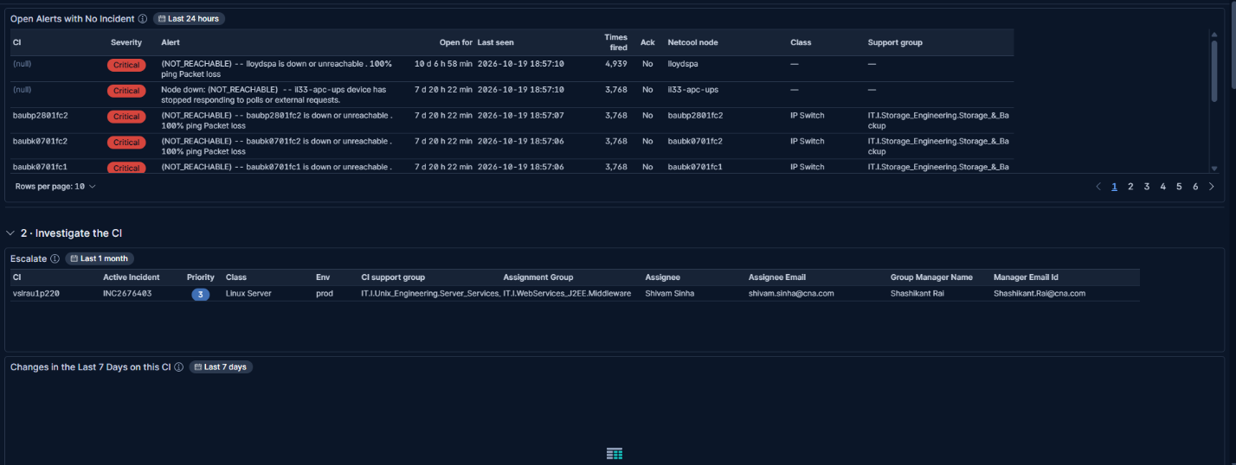
Check | Result
Open Alerts with No Incident: open Netcool alerts on CIs with no open incident | ✅
Escalate: vslrau1p220 · INC2676403 · P3 · Linux Server · prod; assignee Shivam Sinha, manager Shashikant Rai | ✅
Changes in the Last 7 Days: empty | ✅ expected (no changes on this CI)
Notes:
- Open Alerts with No Incident: shows possible blind spots, e.g. switches down for 7 days with no ticket. Worth a look even when you're focused on one incident.
- Escalate answers "who do I call?" in one row: the CI's support group, the incident's assignee, and their manager.
- Changes empty rules out a recent change on this CI as the cause.
Step 3 — The CI's relationships
What to show: what depends on the server and what it depends on, straight from the CMDB.
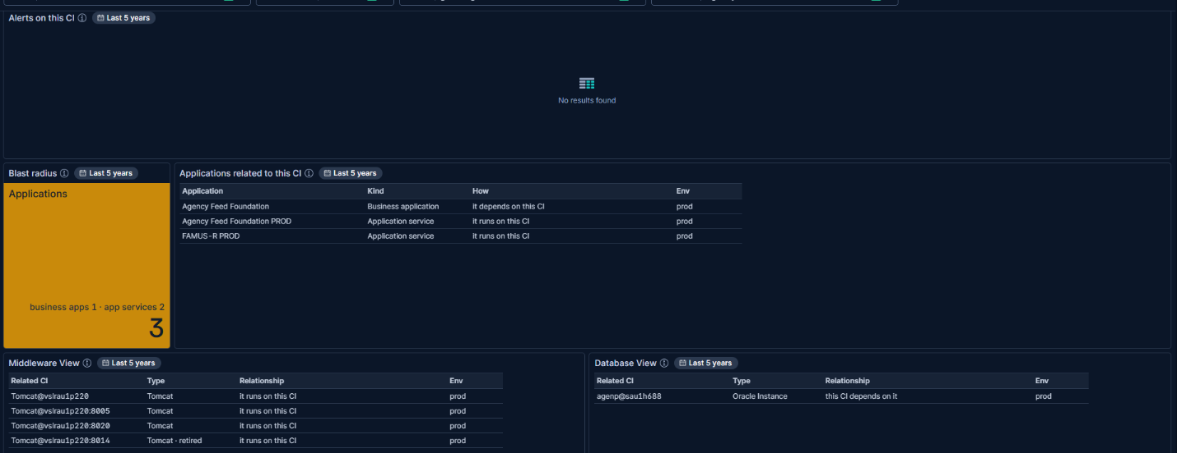
Check | Result
Alerts on this CI: empty | ✅ expected (no Netcool alerts on this CI)
Blast radius: 3 (1 business application, 2 application services) | ✅
Applications related to this CI: Agency Feed Foundation, Agency Feed Foundation PROD, FAMUS-R PROD | ✅
Middleware View: 4 Tomcat instances (one marked retired) | ✅
Database View: Oracle instance agenp@sau1h688 | ✅
Notes:
- Blast radius is amber at 1 or more, red at 5: if this server fails, 3 applications are affected.
- Applications related spells out each relationship ("it runs on this CI", "it depends on this CI"). This is how Agency Feed Foundation was found for the Application control.
- Middleware / Database views come from CMDB records, not live health. The database lives on another server (sau1h688), which is worth checking if the application is slow.
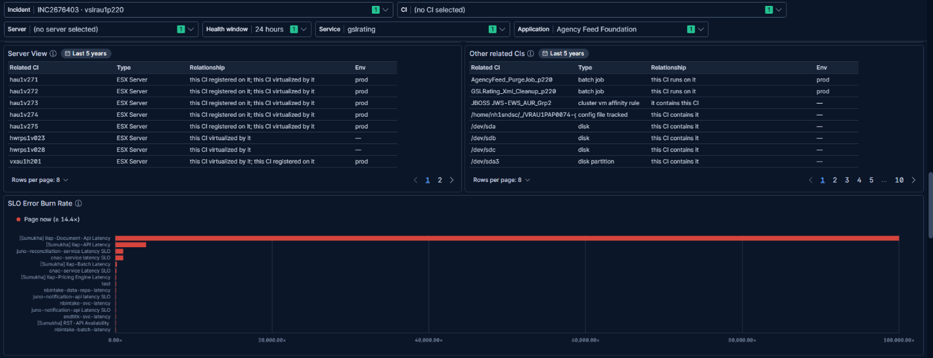
Check | Result
Server View: the ESX hosts it runs on | ✅
Other related CIs: batch jobs, disks, cluster rule | ✅
SLO Error Burn Rate: burning SLOs (no ★ row: the CI has no SLO of its own) | ✅
Notes:
- Server View lists the ESX hosts the server is virtualised on: the next place to look if the VM itself misbehaves.
- Other related CIs catches everything else, e.g. batch jobs that run on the server and its disks. So no CMDB link is hidden.
- SLO Error Burn Rate is estate-wide: SLOs burning their error budget now. A ★ would mark an SLO of this CI.
Step 4 — Application and service health
What to show: whether the applications on this server are healthy, from APM, over the last hour.
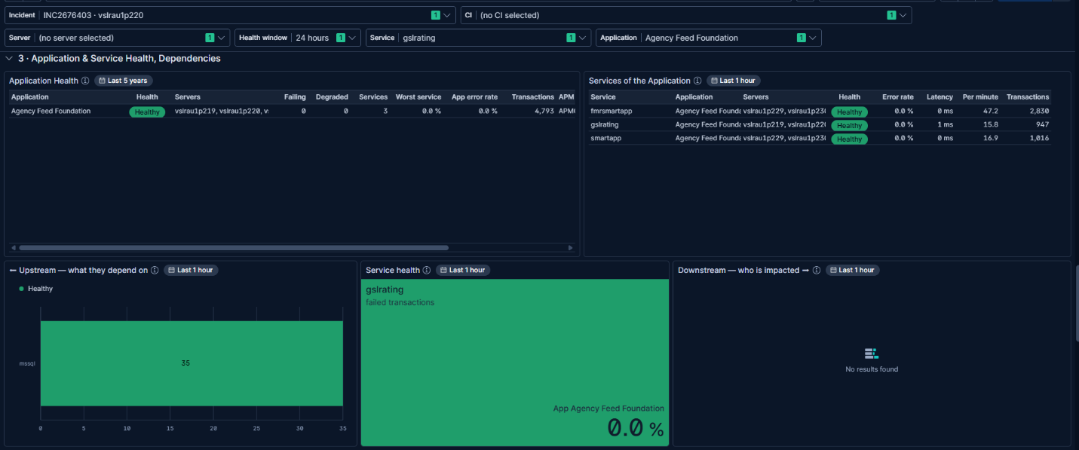
Check | Result
Application Health: Agency Feed Foundation Healthy, 3 services, with its servers | ✅
Services of the Application: fmrsmartapp, gslrating, smartapp, all Healthy, with servers | ✅
Upstream: gslrating depends on mssql (35 calls, Healthy) | ✅
Service health: gslrating, 0.0 % failed | ✅
Downstream: empty | ✅ expected (no HTTP callers in the last hour)
Notes:
- Application Health rolls each application up from its services: Failing at 10 % failed transactions or more, Degraded at 1 % or more.
- The Servers column shows where each service runs (here vslrau1p219, vslrau1p220 …). Typing one into the Server control moves the health panels to that server.
- Read the dependency row left to right: what gslrating depends on (mssql) → gslrating itself → who calls it. Everything is green, so the application is not affected right now.
Step 5 — The server's health
What to show: the server's own health over the Health window: the infrastructure view of the incident.
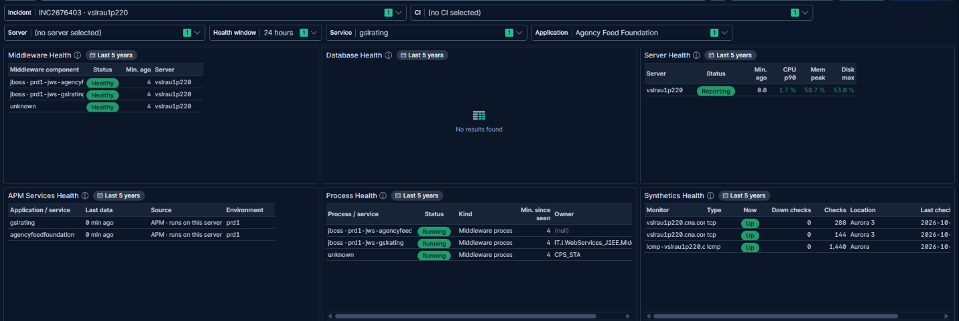
Check | Result
Middleware Health: 2 JBoss instances + 1 unlabelled process, all Healthy | ✅
Database Health: empty | ✅ expected (no database on this server)
Server Health: Reporting; CPU p90 1.7 %, memory 58.7 %, disk 53 % | ✅
APM Services Health: gslrating, agencyfeedfoundation, data 0 min ago | ✅
Process Health: 3 middleware processes Running | ✅
Synthetics Health: 3 monitors Up, 0 down checks | ✅
Notes:
- Server Health turns amber at 80 %, red at 90 %, and "Silent" after 10 minutes without data. Here all three values are green and it is reporting.
- Middleware / Process Health put stopped or silent components first. None here.
- Synthetics checks the server from outside: ping and TCP ports 8445 / 8448 are up. So it is reachable.
- Health window: set it to 15 minutes to see the state now, or to 7 days to look further back.
Step 6 — Logs and related dashboards
What to show: the only place this incident shows any signal.
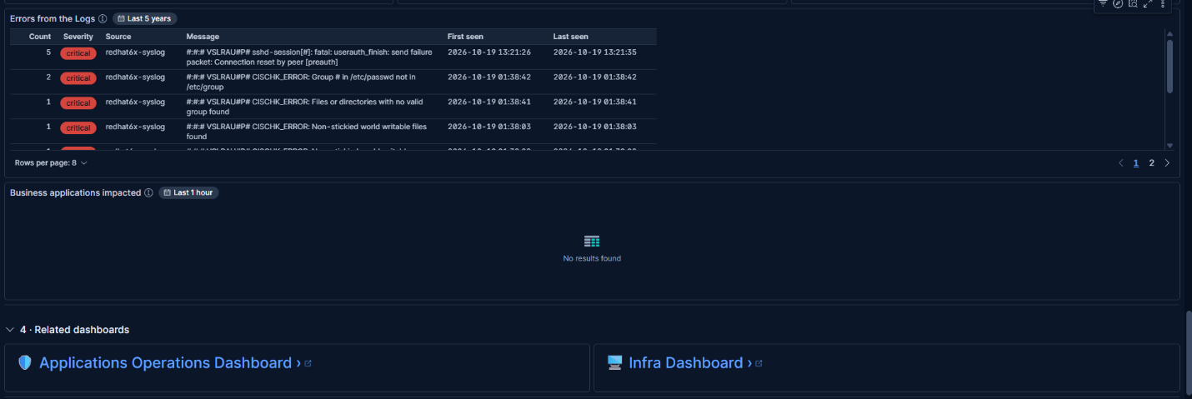
Check | Result
Errors from the Logs: critical sshd and CISCHK_ERROR lines from redhat6x-syslog, grouped with counts | ✅
Business applications impacted: empty | ✅ expected (no callers, as in Downstream)
Links to the Applications Operations and Infra dashboards | ✅
Notes:
- Errors from the Logs groups repeated messages: numbers become #, so one error shows once with a count. Compare First seen with the incident's opened time.
- What the logs show: sshd connection resets (13:21) and CIS compliance-check errors (01:38). Likely the incident's subject, or noise for the assignee to confirm.
- Related dashboards open the full Applications Operations and Infra views for deeper digging.

Outcome
- Server and applications are healthy now. The server is reporting with low CPU and memory, its services have no failed transactions, and its monitors are up.
- The only signals are in the logs: sshd connection resets and CIS compliance errors.
- Escalate to: Shivam Sinha (assignee), then Shashikant Rai (manager); both are named in Escalate.

